**UNIT-I**

**Introduction to Operating System**

**Definition of operating system**

An **operating system** acts as an intermediary between the user of a computer and computer hardware. The purpose of an **operating system** is to provide an environment in which a user can execute programs in a convenient and efficient manner. An **operating system** is software that manages the computer hardware.

or

An **Operating system (OS)** is software which acts as an interface between the end user and computer hardware. Every computer must have at least one OS to run other programs. An application like Chrome, MS Word, Games, etc needs some environment in which it will run and perform its task. The OS helps you to communicate with the computer without knowing how to speak the computer's language. It is **not** possible for the user to use any computer or mobile device 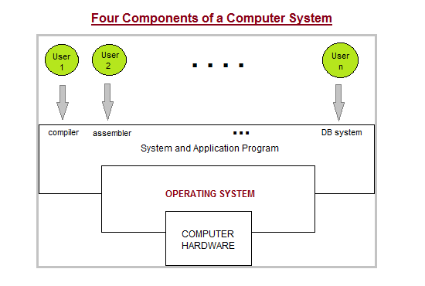

**Two Views of Operating System**

1. User's View
2. System View

**Operating System Management Tasks**

1. **Processor management** which involves putting the tasks into order and pairing them into manageable size before they go to the CPU.
2. **Memory management** which coordinates data to and from RAM (random-access memory) and determines the necessity for virtual memory.
3. **Device management** which provides interface between connected devices.
4. **Storage management** which directs permanent data storage.
5. **Application** which allows standard communication between software and your computer.
6. **User interface** which allows you to communicate with your computer.

**Functions of an Operating System**

In an operating system software performs each of the function:

1. **Process management**:- Process management helps OS to create and delete processes. It also provides mechanisms for synchronization and communication among processes.
2. **Memory management:-** Memory management module performs the task of allocation and de-allocation of memory space to programs in need of this resources.
3. **File management**:- It manages all the file-related activities such as organization storage, retrieval, naming, sharing, and protection of files.
4. **Device Management**: Device management keeps tracks of all devices. This module also responsible for this task is known as the I/O controller. It also performs the task of allocation and de-allocation of the devices.
5. **I/O System Management:** One of the main objects of any OS is to hide the peculiarities of that hardware device from the user.
6. **Secondary-Storage Management**: Systems have several levels of storage which includes primary storage, secondary storage, and cache storage. Instructions and data must be stored in primary storage or cache so that a running program can reference it.
7. **Security**:- Security module protects the data and information of a computer system against malware threat and authorized access.
8. **Command interpretation**: This module is interpreting commands given by the and acting system resources to process that commands.
9. **Networking:** A distributed system is a group of processors which do not share memory, hardware devices, or a clock. The processors communicate with one another through the network.
10. **Job accounting**: Keeping track of time & resource used by various job and users.
11. **Communication management**: Coordination and assignment of compilers, interpreters, and another software resource of the various users of the computer systems.
12. It boots the computer
13. It performs basic computer tasks e.g. managing the various peripheral devices e.g. mouse, keyboard
14. It provides a user interface, e.g. command line, graphical user interface (GUI)
15. It handles system resources such as computer's memory and sharing of the central processing unit (CPU) time by various applications or peripheral devices.
16. It provides file management which refers to the way that the operating system manipulates stores, retrieves and saves data.
17. Error Handling is done by the operating system. It takes preventive measures whenever required to avoid errors.

**Features of Operating System**

Here is a list commonly found important features of an Operating System

* Protected and supervisor mode
* Allows disk access and file systems Device drivers Networking Security.
* Program Execution
* Memory management Virtual Memory Multitasking
* Handling I/O operations
* Manipulation of the file system
* Error Detection and handling
* Resource allocation
* Information and Resource Protection

# Evolution of Operating Systems

The evolution of operating systems is directly dependent on the development of computer systems and how users use them. Here is a quick tour of computing systems through the past fifty years in the timeline.

## Early Evolution

* 1945: **ENIAC**, Moore School of Engineering, University of Pennsylvania.
* 1949: **EDSAC** and **EDVAC**
* 1949: **BINAC** - a successor to the ENIAC
* 1951: **UNIVAC** by Remington
* 1952: **IBM** 701
* 1956: The interrupt
* 1954-1957: **FORTRAN** was developed

## Operating Systems - Late 1950s

By the late 1950s Operating systems were well improved and started supporting following usages:

* It was able to perform **Single stream batch processing**.
* It could use Common, standardized, input/output routines for device access.
* Program transition capabilities to reduce the overhead of starting a new job was added.
* **Error recovery** to clean up after a job terminated abnormally was added.
* Job control languages that allowed users to specify the job definition and resource requirements were made possible.

**Operating Systems - In 1960s**

* 1961: The dawn of minicomputers
* 1962: Compatible Time-Sharing System (CTSS) from MIT
* 1963: Burroughs Master Control Program (MCP) for the B5000 system
* 1964: IBM System/360
* 1960s: Disks became mainstream
* 1966: Minicomputers got cheaper, more powerful, and really useful.
* 1967-1968: **Mouse** was invented.
* 1964 and onward: Multics
* 1969: The UNIX Time-Sharing System from Bell Telephone Laboratories.
* Here is a list of Operating Systems with the latest Market Share

|  |  |
| --- | --- |
| **OS Name** | **Share** |
| Windows | 40.34 |
| Android | 37.95 |
| iOS | 15.44 |
| Mac OS | 4.34 |
| Linux | 0.95 |
| Chrome OS | 0.14 |
| Windows Phone OS | 0.06 |

**Supported OS Features by 1970s**

* **Multi User** and **Multi tasking** was introduced.
* **Dynamic address** translation hardware and **Virtual machines** came into picture.
* **Modular architectures** came into existence.
* Personal, interactive systems came into existence.

**Accomplishments after 1970**

* 1971: Intel announces the microprocessor
* 1972: IBM comes out with VM: the Virtual Machine Operating System
* 1973: UNIX 4th Edition is published
* 1973: Ethernet
* 1974 The Personal Computer Age begins
* 1974: Gates and Allen wrote BASIC for the Altair
* 1976: Apple II
* August 12, 1981: IBM introduces the IBM PC
* 1983 Microsoft begins work on MS-Windows
* 1984 Apple Macintosh comes out
* 1990 Microsoft Windows 3.0 comes out
* 1991 GNU/Linux
* 1992 The first Windows virus comes out
* 1993 Windows NT
* 2007: iOS
* 2008: Android OS

And as the research and development work continues, we are seeing new operating systems being developed and existing ones getting improved and modified to enhance the overall user experience, making operating systems fast and efficient like never before.

Also, with the onset of new devies like wearables, which includes, Smart Watches, Smart Glasses, VR gears etc, the demand for unconventional operating systems is also rising.

# Types of Operating Systems

Following are some of the most widely used types of Operating system.

1. Simple Batch System
2. Multiprogramming Batch System
3. Multiprocessor System
4. Desktop System
5. Distributed Operating System
6. Clustered System
7. Real time Operating System
8. Handheld System

## Simple Batch Systems

* In this type of system, there is **no direct interaction between user and the computer**.
* The user has to submit a job (written on cards or tape) to a computer operator.
* Then computer operator places a batch of several jobs on an input device.
* Jobs are batched together by type of languages and requirement.
* Then a special program, the monitor, manages the execution of each program in the batch.
* The monitor is always in the main memory and available for execution.

#### Advantages of Simple Batch Systems

1. No interaction between user and computer.
2. No mechanism to prioritise the processes.

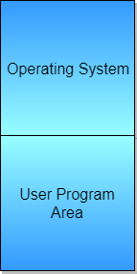

## Multiprogramming Batch Systems

* In this the operating system picks up and begins to execute one of the jobs from memory.
* Once this job needs an I/O operation operating system switches to another job (CPU and OS always busy).
* Jobs in the memory are always less than the number of jobs on disk(Job Pool).
* If several jobs are ready to run at the same time, then the system chooses which one to run through the process of **CPU Scheduling**.
* In Non-multiprogrammed system, there are moments when CPU sits idle and does not do any work.
* In Multiprogramming system, CPU will never be idle and keeps on processing.

**Time Sharing Systems:** are very similar to Multiprogramming batch systems. In fact time sharing systems are an extension of multiprogramming systems.

In Time sharing systems the prime focus is on **minimizing the response time**, while in multiprogramming the prime focus is to maximize the CPU usage.

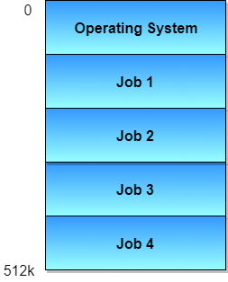

## Multiprocessor Systems

A Multiprocessor system consists of several processors that share a common physical memory. Multiprocessor system provides higher computing power and speed. In multiprocessor system all processors operate under single operating system. Multiplicity of the processors and how they do act together are transparent to the others.

#### Advantages of Multiprocessor Systems

1. Enhanced performance
2. Execution of several tasks by different processors concurrently, increases the system's throughput without speeding up the execution of a single task.
3. If possible, system divides task into many subtasks and then these subtasks can be executed in parallel in different processors. Thereby speeding up the execution of single tasks.

## Desktop Systems

Earlier, CPUs and PCs lacked the features needed to protect an operating system from user programs. PC operating systems therefore were neither **multiuser** nor **multitasking**. However, the goals of these operating systems have changed with time; instead of maximizing CPU and peripheral utilization, the systems opt for maximizing user convenience and responsiveness. These systems are called **Desktop Systems** and include PCs running Microsoft Windows and the Apple Macintosh. Operating systems for these computers have benefited in several ways from the development of operating systems for **mainframes**.

**Microcomputers** were immediately able to adopt some of the technology developed for larger operating systems. On the other hand, the hardware costs for microcomputers are sufficiently **low** that individuals have sole use of the computer, and CPU utilization is no longer a prime concern. Thus, some of the design decisions made in operating systems for mainframes may not be appropriate for smaller systems.

## Distributed Operating System

The motivation behind developing distributed operating systems is the availability of powerful and inexpensive microprocessors and advances in communication technology.

These advancements in technology have made it possible to design and develop distributed systems comprising of many computers that are inter connected by communication networks. The main benefit of distributed systems is its low price/performance ratio.

#### Advantages Distributed Operating System

1. As there are multiple systems involved, user at one site can utilize the resources of systems at other sites for resource-intensive tasks.
2. Fast processing.
3. Less load on the Host Machine.

### Types of Distributed Operating Systems

Following are the two types of distributed operating systems used:

1. Client-Server Systems
2. Peer-to-Peer Systems

#### Client-Server Systems

**Centralized systems** today act as **server systems** to satisfy requests generated by **client systems**.

The general structure of a client-server system is depicted in the figure below:

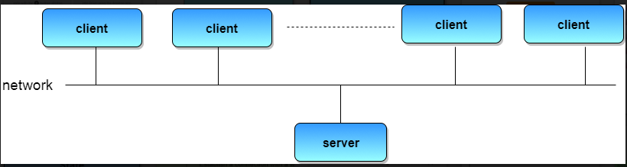

Server Systems can be broadly categorized as: **Compute Servers** and **File Servers**.

* **Compute Server systems**, provide an interface to which clients can send requests to perform an action, in response to which they execute the action and send back results to the client.
* **File Server systems**, provide a file-system interface where clients can create, update, read, and delete files.

#### Peer-to-Peer Systems

The growth of computer networks - especially the Internet and World Wide Web (WWW) – has had a profound influence on the recent development of operating systems. When PCs were introduced in the 1970s, they were designed for **personal** use and were generally considered standalone computers. With the beginning of widespread public use of the Internet in the 1990s for electronic mail and FTP, many PCs became connected to computer networks.

In contrast to the **Tightly Coupled** systems, the computer networks used in these applications consist of a collection of processors that do not share memory or a clock. Instead, each processor has its own local memory. The processors communicate with one another through various communication lines, such as high-speed buses or telephone lines. These systems are usually referred to as loosely coupled systems ( or distributed systems). The general structure of a client-server system is depicted in the figure below:

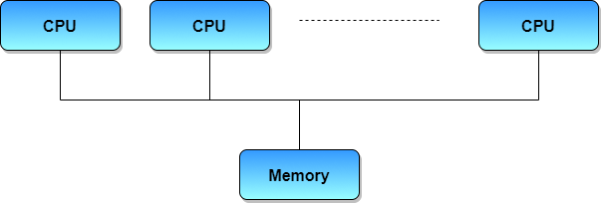

## Clustered Systems

* Like parallel systems, clustered systems gather together multiple CPUs to accomplish computational work.
* Clustered systems differ from parallel systems, however, in that they are composed of two or more individual systems coupled together.
* The definition of the term clustered is **not concrete;** the general accepted definition is that clustered computers share storage and are closely linked via LAN networking.
* Clustering is usually performed to provide **high availability**.
* A layer of cluster software runs on the cluster nodes. Each node can monitor one or more of the others. If the monitored machine fails, the monitoring machine can take ownership of its storage, and restart the application(s) that were running on the failed machine. The failed machine can remain down, but the users and clients of the application would only see a brief interruption of service.
* **Asymmetric Clustering -** In this, one machine is in hot standby mode while the other is running the applications. The hot standby host (machine) does nothing but monitor the active server. If that server fails, the hot standby host becomes the active server.
* **Symmetric Clustering -** In this, two or more hosts are running applications, and they are monitoring each other. This mode is obviously more efficient, as it uses all of the available hardware.
* **Parallel Clustering -** Parallel clusters allow multiple hosts to access the same data on the shared storage. Because most operating systems lack support for this simultaneous data access by multiple hosts, parallel clusters are usually accomplished by special versions of software and special releases of applications.

Clustered technology is rapidly changing. Clustered system's usage and it's features should expand greatly as **Storage Area Networks (SANs)**. SANs allow easy attachment of multiple hosts to multiple storage units. Current clusters are usually limited to two or four hosts due to the complexity of connecting the hosts to shared storage.

## Real Time Operating System

It is defined as an operating system known to give maximum time for each of the critical operations that it performs, like OS calls and interrupt handling.

The Real-Time Operating systems which guarantees the maximum time for critical operations and complete them on time are referred to as **Hard Real-Time Operating Systems.**

### While the real-time operating systems that can only guarantee a maximum of the time, i.e. the critical task will get priority over other tasks, but no assurity of completing it in a defined time.

### These systems are referred to as Soft Real-Time Operating Systems, Hard real-time systems

Hard real-time systems guarantee that critical tasks complete on time. In hard real-time systems, secondary storage is limited or missing and the data is stored in ROM. In these systems, virtual memory is almost never found.

### Soft real-time systems

Soft real-time systems are less restrictive. A critical real-time task gets priority over other tasks and retains the priority until it completes. Soft real-time systems have limited utility than hard real-time systems. For example, multimedia, virtual reality, Advanced Scientific Projects like undersea exploration and planetary rovers, etc.

**Handheld Systems:**

Handheld systems include Personal Digital Assistants (PDAs), such as Palm-Pilots or Cellular Telephones with connectivity to a network such as the Internet. They are usually of limited size due to which most handheld devices have a small amount of memory, include slow processors, and feature small display screens.

* Many handheld devices have between 512 KB and 8 MB of memory. As a result, the operating system and applications must manage memory efficiently. This includes returning all allocated memory back to the memory manager once the memory is no longer being used.
* Currently, many handheld devices do not use virtual memory techniques, thus forcing program developers to work within the confines of limited physical memory.
* Processors for most handheld devices often run at a fraction of the speed of a processor in a PC. Faster processors require more power. To include a faster processor in a handheld device would require a larger battery that would have to be replaced more frequently.
* The last issue confronting program designers for handheld devices is the small display screens typically available. One approach for displaying the content in web pages is web clipping, where only a small subset of a web page is delivered and displayed on the handheld device.

Some handheld devices may use wireless technology such as Bluetooth, allowing remote access to e-mail and web browsing. Cellular telephones with connectivity to the Internet fall into this category. Their use continues to expand as network connections become more available and other options such as cameras and MP3 players expand their utility.

## What is a Kernel?

The kernel is the central component of a computer operating systems. The only job performed by the kernel is to the manage the communication between the software and the hardware. A Kernel is at the nucleus of a computer. It makes the communication between the hardware and software possible. While the Kernel is the innermost part of an operating system, a shell is the outermost one.

## Features of Kennel

* Low-level scheduling of processes
* Inter-process communication
* Process synchronization
* Context switching

### Types of Kernels

There are many types of kernels that exists, but among them, the two most popular kernels are:

1**. Monolithic**

A monolithic kernel is a single code or block of the program. It provides all the required services offered by the operating system. It is a simplistic design which creates a distinct communication layer between the hardware and software.

**2. Microkernel’s**

Microkernel manages all system resources. In this type of kernel, services are implemented in different address space. The user services are stored in user address space, and kernel services are stored under kernel address space. So, it helps to reduce the size of both the kernel and operating system.

**Difference between Firmware and Operating System**

|  |  |
| --- | --- |
| **Firmware** | **Operating System** |
| Firmware is one kind of programming that is embedded on a chip in the device which controls that specific device. | OS provides functionality over and above that which is provided by the firmware. |
| Firmware is programs that been encoded by the manufacture of the IC or something and cannot be changed. | OS is a program that can be installed by the user and can be changed. |
| It is stored on non-volatile memory. | OS is stored on the hard drive. |

**Difference between 32-Bit vs. 64 Bit Operating System**

|  |  |  |
| --- | --- | --- |
| **Parameters** | **32. Bit** | **64. Bit** |
| Architecture and Software | Allow 32 bit of data processing simultaneously | Allow 64 bit of data processing simultaneously |
| Compatibility | 32-bit applications require 32-bit OS and CPUs. | 64-bit applications require a 64-bit OS and CPU. |
| Systems Available | All versions of Windows 8, Windows 7, Windows Vista, and Windows XP, Linux, etc. | Windows XP Professional, Vista, 7, Mac OS X and Linux. |
| Memory Limits | 32-bit systems are limited to 3.2 GB of RAM. | 64-bit systems allow a maximum 17 Billion GB of RAM. |

**The advantage of using Operating System**

* Allows you to hide details of hardware by creating an abstraction
* Easy to use with a GUI
* Offers an environment in which a user may execute programs/applications
* The operating system must make sure that the computer system convenient to use
* Operating System acts as an intermediary among applications and the hardware components
* It provides the computer system resources with easy to use format
* Acts as an intermediate between all hardware's and software's of the system

**Disadvantages of using Operating System**

* If any issue occurs in OS, you may lose all the contents which have been stored in your system
* Operating system's software is quite expensive for small size organization which adds burden on them. Example Windows
* It is never entirely secure as a threat can occur at any time.

**Applications of Operating System**

Following are some of the important activities that an Operating System performs

* **Security** − By means of password and similar other techniques, it prevents unauthorized access to programs and data.
* **Control over system performance** − Recording delays between request for a service and response from the system.
* **Job accounting** − Keeping track of time and resources used by various jobs and users.
* **Error detecting aids** − Production of dumps, traces, error messages, and other debugging and error detecting aids.
* **Coordination between other software**
* **and users** − Coordination and assignment of compilers, interpreters, assemblers and other software to the various users of the computer systems.

Operating System provides services to both the users and to the programs.

* It provides programs an environment to execute.
* It provides users the services to execute the programs in a convenient manner.

**Operating System Services**

* Program execution
* I/O operations
* File System manipulation
* Communication
* Error Detection
* Resource Allocation
* Protection

**Program execution**

Operating systems handle many kinds of activities from user programs to system programs like printer spooler, name servers, file server, etc. Each of these activities is encapsulated as a process.

A process includes the complete execution context (code to execute, data to manipulate, registers, OS resources in use). Following are the major activities of an operating system with respect to program management −

* Loads a program into memory.
* Executes the program.
* Handles program's execution.
* Provides a mechanism for process synchronization.
* Provides a mechanism for process communication.
* Provides a mechanism for deadlock handling.

**I/O Operation**

An I/O subsystem comprises of I/O devices and their corresponding driver software. Drivers hide the peculiarities of specific hardware devices from the users.

An Operating System manages the communication between user and device drivers.

* I/O operation means read or write operation with any file or any specific I/O device.
* Operating system provides the access to the required I/O device when required.

**File system manipulation**

A file represents a collection of related information. Computers can store files on the disk (secondary storage), for long-term storage purpose. Examples of storage media include magnetic tape, magnetic disk and optical disk drives like CD, DVD. Each of these media has its own properties like speed, capacity, data transfer rate and data access methods.

A file system is normally organized into directories for easy navigation and usage. These directories may contain files and other directions. Following are the major activities of an operating system with respect to file management −

* Program needs to read a file or write a file.
* The operating system gives the permission to the program for operation on file.
* Permission varies from read-only, read-write, denied and so on.
* Operating System provides an interface to the user to create/delete files.
* Operating System provides an interface to the user to create/delete directories.
* Operating System provides an interface to create the backup of file system.

**Communication**

In case of distributed systems which are a collection of processors that do not share memory, peripheral devices, or a clock, the operating system manages communications between all the processes. Multiple processes communicate with one another through communication lines in the network.

The OS handles routing and connection strategies, and the problems of contention and security. Following are the major activities of an operating system with respect to communication −

* Two processes often require data to be transferred between them
* Both the processes can be on one computer or on different computers, but are connected through a computer network.
* Communication may be implemented by two methods, either by Shared Memory or by Message Passing.

**Error handling**

Errors can occur anytime and anywhere. An error may occur in CPU, in I/O devices or in the memory hardware. Following are the major activities of an operating system with respect to error handling −

* The OS constantly checks for possible errors.
* The OS takes an appropriate action to ensure correct and consistent computing.

**Resource Management**

In case of multi-user or multi-tasking environment, resources such as main memory, CPU cycles and files storage are to be allocated to each user or job. Following are the major activities of an operating system with respect to resource management –

* The OS manages all kinds of resources using schedulers.
* CPU scheduling algorithms are used for better utilization of CPU.

**Protection**

Considering a computer system having multiple users and concurrent execution of multiple processes, the various processes must be protected from each other's activities.

Protection refers to a mechanism or a way to control the access of programs, processes, or users to the resources defined by a computer system. Following are the major activities of an operating system with respect to protection −

* The OS ensures that all access to system resources is controlled.
* The OS ensures that external I/O devices are protected from invalid access attempts.
* The OS provides authentication features for each user by means of passwords.

### System Calls

1. Process Management

Scheduling, deadlock detection is transparent.

* 1. fork, vfork, exit, exec
  2. wait
  3. signals, pipes, streams, sockets

1. Memory management

For the most part, transparent to the user.

* 1. malloc, free

1. I/O Device Management

Devices are treated as files, so I/O devices are supported by the file system.

1. File System
   1. creat, open, close
   2. lseek, read, write
   3. stat, chmod, chown
   4. link, unlink
   5. mkdir, rmdir
   6. sync

# Operating System - Properties

## Batch processing

Batch processing is a technique in which an Operating System collects the programs and data together in a batch before processing starts. An operating system does the following activities related to batch processing −

* The OS defines a job which has predefined sequence of commands, programs and data as a single unit.
* The OS keeps a number a jobs in memory and executes them without any manual information.
* Jobs are processed in the order of submission, i.e., first come first served fashion.
* When a job completes its execution, its memory is released and the output for the job gets copied into an output spool for later printing or processing.

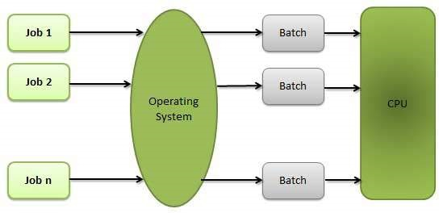

### Advantages

* Batch processing takes much of the work of the operator to the computer.
* Increased performance as a new job get started as soon as the previous job is finished, without any manual intervention.

### Disadvantages

* Difficult to debug program.
* A job could enter an infinite loop.
* Due to lack of protection scheme, one batch job can affect pending jobs.

## Multitasking

Multitasking is when multiple jobs are executed by the CPU simultaneously by switching between them. Switches occur so frequently that the users may interact with each program while it is running. An OS does the following activities related to multitasking −

* The user gives instructions to the operating system or to a program directly, and receives an immediate response.
* The OS handles multitasking in the way that it can handle multiple operations/executes multiple programs at a time.
* Multitasking Operating Systems are also known as Time-sharing systems.
* These Operating Systems were developed to provide interactive use of a computer system at a reasonable cost.
* A time-shared operating system uses the concept of CPU scheduling and multiprogramming to provide each user with a small portion of a time-shared CPU.
* Each user has at least one separate program in memory.

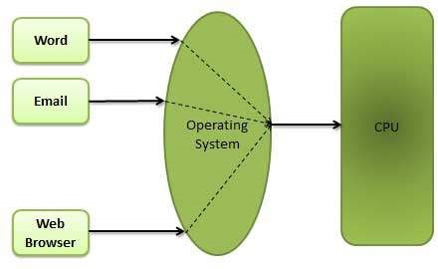

* A program that is loaded into memory and is executing is commonly referred to as a **process**.
* When a process executes, it typically executes for only a very short time before it either finishes or needs to perform I/O.
* Since interactive I/O typically runs at slower speeds, it may take a long time to complete. During this time, a CPU can be utilized by another process.
* The operating system allows the users to share the computer simultaneously. Since each action or command in a time-shared system tends to be short, only a little CPU time is needed for each user.
* As the system switches CPU rapidly from one user/program to the next, each user is given the impression that he/she has his/her own CPU, whereas actually one CPU is being shared among many users.

## Multiprogramming

Sharing the processor, when two or more programs reside in memory at the same time, is referred as **multiprogramming**. Multiprogramming assumes a single shared processor. Multiprogramming increases CPU utilization by organizing jobs so that the CPU always has one to execute.

The following figure shows the memory layout for a multiprogramming system.

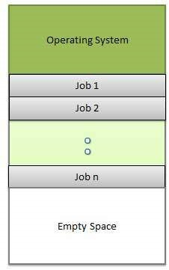

An OS does the following activities related to multiprogramming.

* The operating system keeps several jobs in memory at a time.
* This set of jobs is a subset of the jobs kept in the job pool.
* The operating system picks and begins to execute one of the jobs in the memory.
* Multiprogramming operating systems monitor the state of all active programs and system resources using memory management programs to ensures that the CPU is never idle, unless there are no jobs to process.

### Advantages

* High and efficient CPU utilization.
* User feels that many programs are allotted CPU almost simultaneously.

### Disadvantages

* CPU scheduling is required.
* To accommodate many jobs in memory, memory management is required.

**Summary**

* An operating system is a software which acts as an interface between the end user and computer hardware
* Operating systems were first developed in the late 1950s to manage tape storage
* The kernel is the central component of a computer operating systems. The only job performed by the kernel is to the manage the communication between the software and the hardware
* Two most popular kernels are Monolithic and MicroKernels.
* Process, Device, File, I/O, Secondary-Storage, Memory management are various functions of an Operating System
* Batch, Multitasking/Time Sharing, Multiprocessing, Real Time, Distributed, Network, Mobile are various types of Operating Systems.